February 2026: Vero Beach First Friday Art Stroll, Tabling Event

Myself and a group of concerned local citizens, who have self-organized into the Friends of Democracy, had a 'Tabling Event' this past Friday at the Downtown Art Stroll. The objective of the event was to talk to and inform our fellow citizens of the threats to our Democracy at the National and State levels. We spoke to hundreds of citizens, most of whom were also concerned about the threats to our democracy and well-being!

I hope it is not too late for you to cover this 'event'. Let me know if you would like to interview any of the participants whose comments are below.

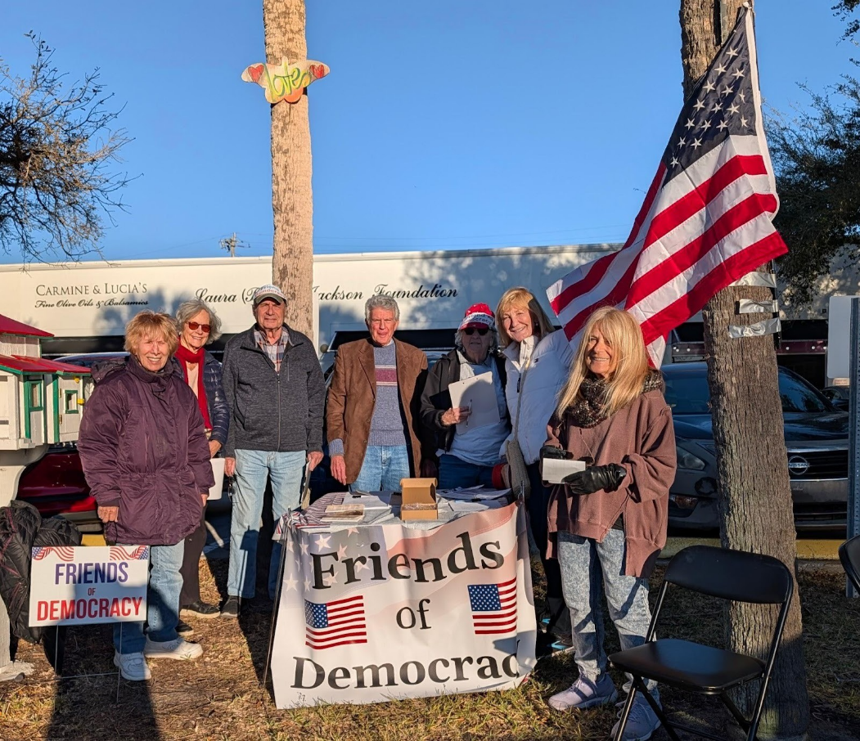
Most of the people taking part had never done this type of face-to-face grassroots action before.

Some comments from the Tabling Team members:

Bob:
I was at the tabling event on Friday night and learned a lot. Mostly watching Suzy and Herb stopping and engage people who were just walking down the street. I was in sales, but I never tried to sell like that! It felt uncomfortable, but to my surprise it wasn't so bad, and many people responded. It may continue to feel uncomfortable, but it's important to remember why you're doing it. A minor discomfort for an important reason.

Joanne Howes:
A resounding success! As a seasoned activist and a person who thrives on interaction, I thoroughly enjoyed this opportunity.to voice my concerns about the direction of our country and listen to what others are thinking.
Many stopped to chat; all didn't agree, but that's what democracy looks like. Some enthusiastically signed up to be part of FoD, others thanked us for being there, and some were already active with the Democratic Party
The camaraderie of the other participants made last night a fun and inspiring evening

Anne:
It was such a fun evening!
Not only did I reach out with a lot of Floridians but enjoyed being with our Democracy Tabling Team.
I felt their support at all times and later, over a glass of wine, enjoyed sharing our stories, both positive and negative. I really think it makes a difference
Many, many people signed up and were keen to spread the word. It just confirms how necessary this work is! I am ready to go anytime. It's fun and worthwhile.

Jeff:
I was also at the tabling event on Friday and was pleasantly surprised at how well it went. It was my first time doing something like this.
The most satisfying aspect for me was the number of people who thanked us for being out there. Even several former Trump voters — while not disagreeing with all, or perhaps even most, of Trump's policy goals — acknowledged the need to change/reform his methods (and not just regarding ICE). To me, this is our most important target audience. They need to be encouraged to speak with their like-minded friends and be proactive, i.e. support and vote for "pro-democracy" candidates wherever the opportunity arises.
My thanks to all the other participants on Friday and, of course, to our fearless leader.

Larry:
I took part in the tabling event Friday from 5 to about 6:30, when foot traffic dropped off. My approach was to say, 'We are out on the street tonight talking to people about democracy. Would you like to talk about democracy?' The responses ranged from yes to we're just having fun tonight to no. I have to say I actually enjoyed talking to people, even the negative ones. This one lady identified as Republican but agreed to talk with me and did so for about 5 minutes. She was concerned about election fraud, mentioning the 2020 election. So I explained to her that the Trump administration in 2020 and early 2021 went to court 63 times and lost 63 times. I also explained that Rudy Giuliani would talk about fraud on TV but had no proof, and that's why they lost all the cases. She said she was not aware of that. I've gone on way too long, so I will end by thanking everyone who took part.

Gwen:
I really enjoyed our evening together on Thursday and was surprised by the reception we got. People actually stopped and engaged with us. Some were straight out of MAGA and were antagonistic….it was hard to listen to them praise Trump and ICE, and criticize the Protestors and Democrats. But overall, I felt our group got some people thinking, and they thanked us for our efforts.

I need to think about how to engage more effectively with pedestrians. But the evening was fun and a success. We'll only get better, and hats off to Herb and Suzi for their vision and persistence. Gwen

Elaine:
Although I couldn't get to the tabling event, I was happy to have dinner with all of you. Upon leaving the restaurant with Bob, Herb, and Susie,
A lovely couple at the restaurant stopped us. This couple was scared. She is Cuban and a nationalized citizen. He is from Panama. They expressed appreciation that Caucasians like Friends of Democracy are out
on the street on their behalf.
I was extremely touched by them and realized how important the group is.

